**A Clock Angle**

There are 360 Longitudes on the Earth, which are equidistant vertical imaginary lines drawn on the Earth, separated by 1 degree each from center of the Earth. Period of the rotation of the Earth on its axis is 24 hours. All countries have their own official times and hence time zones.

UTC is universal time coordinate which passes through 0 (Zero degree) longitude.

Time at a particular location on Earth can be calculated using period of the rotation of Earth and longitude of that particular location. For example, Indian time zone IST (Indian standard Time) is located at 82.5° E longitude. Hence, Indian time can be calculated as below:-

IST = UTC + (24/360)*82.5 = UTC + 5:30Hrs

Now suppose we changed period of rotation of the earth using some imaginary power, this will change the time at every longitude on the earth.

Calculate the smallest angle between hour and minute hand of the clock , which shows the difference of time at a particular longitude and the time at UTC  i.e.**we have to take smaller of the two angle formed between hour and minute hand.**

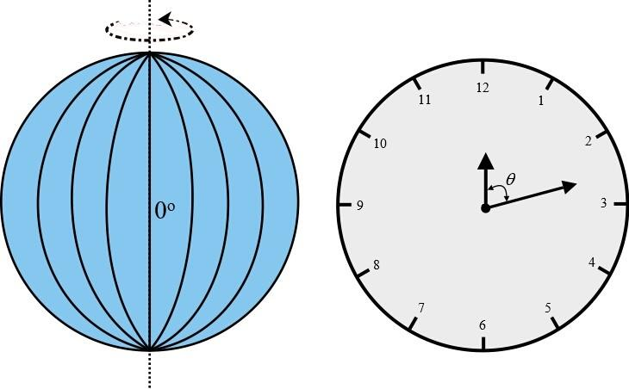

Constraints

To show the time difference on clock, 12-hour clock (as shown below) shall be used, irrespective of period of the earth's rotation, for this question only.

Input Format

1. Period of the earth’s rotation in Hours (Integer only)

2. Value of Longitude up to 2 place of decimal

Output

Smallest angle between hour and minute hand of the clock, which shows the difference between time at a particular longitude and time at UTC, up to 2 decimal places.

Test Case

Explanation

Example 1

Input

24

82.50

Output

15.00

Explanation

If period of rotation of earth is 24 hours then time at 82.5 degree longitude will be (24/360)*82.50 = 5:30 and minimum angle at this time between minute and hour hand will be 15 degree.

Example 2

Input

12

360.00

Output

0.00

Explanation

If period of rotation of earth is 12 hours then time at 360 degree longitude will be (12/360)*360 = 12:00 and minimum angle at this time between minute and hour hand will be 0 degree.

## B Lexi String

### Problem Description

Little Jill jumbled up the order of the letters in our dictionary. Now, Jack uses this list to find the smallest lexicographical string that can be made out of this new order. Can you help him?

You are given a string **P** that denotes the new order of letters in the English dictionary.

You need to print the smallest lexicographic string made from the given string **S**.

### Constraints

1 <= T <= 1000

Length (P) = 26

1 <= length (S) <= 100

All characters in the string S, P are in lowercase

### Input Format

The first line contains number of test cases T

The second line has the string P

The third line has the string S

### Output

Print a single string in a new line for every test case giving the result

### Test Case

### Explanation

Example 1

Input

2

polikujmnhytgbvfredcxswqaz

abcd

qwryupcsfoghjkldezxvbintma

ativedoc

Output

bdca

codevita

Explanation

The transformed smallest lexicographical strings are in order they would be if order of letters are changed to string **P**

## C Marathon Winner

### Problem Description

Race is generally organized by distance but this race will be organized by time.

In order to predict the winner we will check every 2 seconds.

Let’s say total race time is 7 seconds we will check for (7-1) seconds.

For 7 sec : We will check who is leading at 2 sec, 4 sec and 6 sec.

Participant who is leading more number of times is winner from prediction perspective.

Now our task is to predict a winner in this marathon.

Note:

1)At particular time let say at 4th second, top two (top N, in general) participants are at same distance, then in this case both are leading we will increase count for both (all N).

2)And after calculating at all time slices, if number of times someone is leading, is same for two or more participants, then one who come first in input sequence will be the winner.

Ex: If participant 2 and 3 are both leading with same number, participant 2 will be the winner.

### Constraints

1 <= T <= 100

1 <= N <= 100

### Input Format

First line contains a single integer N denoting the number of participants

Second line contains a single integer T denoting the total time in seconds of this Marathon.

Next N lines (for each participant) are as follows :

We have T+1 integers separated by space.

First T integers are as follow:

ith integer denotes the number of steps taken by the participant at the ith second.

T+1st integer denotes the Distance (in meters) of each step.

### Output

Index of Marathon winner, where index starts with 1.

### Test Case

### Explanation

Example 1

Input

3

8

2 2 4 3 5 2 6 2 3

3 5 7 4 3 9 3 2 2

1 2 4 2 7 5 3 2 4

Output

2

Explanation

3 (No. of candidate)

8 (Total time of Sprint (In seconds))

2 2 4 3 5 2 6 2 3 ( data for 1st candidate. First 8 integers denote number of steps per second and last integer denotes distance covered in each step i.e. 3).

3 5 7 4 3 9 3 2 2 (similarly, 2nd candidate’s data).

1 2 4 2 7 5 3 2 4 (similarly, 3rd candidate’s data).

At time 2: Here 2nd marathoner is leading

12 (2*3+2*3)

16 (3*2+5*2)

12 (1*4+2*4)

At time 4 :Here also 2nd marathoner is leading

33 ( 2*3+2*3 +4*3+3*3)

38

36

At time 6 :Here 3rd marathoner is leading

57

62

84

Output:

2

Since, 2nd marathoner is leading more number of times, so 2 is the winner.

## D Collision Course

### Problem Description

On a busy road, multiple cars are passing by. A simulation is run to see what happens if brakes fail for all cars on the road. The only way for them to be safe is if they don't collide and pass by each other. The goal is to identify whether any of the given cars would collide or pass by each other safely around a Roundabout. Think of this as a reference point O ( Origin with coordinates (0,0) ), but instead of going around it, cars pass through it.

Considering that each car is moving in a straight line towards the origin with individual uniform speed. Cars will continue to travel in that same straight line even after crossing origin. Calculate the number of collisions that will happen in such a scenario.

Note : - Calculate collisions only at origin. Ignore the other collisions. Assume that each car continues on its respective path even after the collision without change of direction or speed for an infinite distance.

### Constraints

1<=C<=10^5

-10^9 <= x,y <= 10^9

0 < v < 10^9.

### Input Format

The first line contains an integer C, denoting the number of cars being considered that are passing by around the origin.

Next C lines contain 3 space delimited values, first two of them being for position coordinates (x,y) in 2D space and the third one for speed (v).

### Output

A single integer Q denoting the number of collisions at origin possible for given set of cars.

### Test Case

### Explanation

Example 1

Input

5

5 12 1

16 63 5

-10 24 2

7 24 2

-24 7 2

Output

4

Explanation

Let the 5 cars be A, B, C, D, and E respectively.

4 Collisions are as follows -

1) A & B.

2) A & C.

3) B & C.

4) D & E.

## E Car Optimization

### Problem Description

Aakash, a boy working at a parking lot has been given the responsibility to park the cars coming at the entrance of the parking lot.

There are three types of cars viz. large, medium and small. The parking lot has three types of slots viz. large, medium and small. The large cars cannot be parked in a medium or a small slot, and the medium cars cannot be parked in a small slot.

The charges for parking depend on the size of the slot in which it has been parked, and not on the size of the car itself. The parking charges are as follows

· Charges for a large parking slot are 100 per hour used

· Charges for a medium parking slot are 75 per hour used

· Charges for a small parking slot are 50 per hour used

Customers to the parking lot must indicate the size of their car, and their arrival and departure times to the lot one day in advance. The arrival and departure times will be whole hours. Aakash has been given a list of the customers, the size of their cars, and their arrival and departure times. Of course, he also knows the number of large, medium and small parking slots.

He has been told to maximize the revenue received from the customers. He has the freedom to refuse to allow a car to be admitted into the parking lot (of course that customer will not pay any parking charges). However, if a car is admitted into the parking lot, it must be parked in one of the cheapest (least parking charges) available slot into which it will fit. If multiple cars come at the same time, he can choose the order in which cars are parked. Also, no car which has been parked may be moved until its departure time.

Help him to arrange the cars in order to acquire maximum revenue.

### Constraints

0 < l, m, s <= 50

n <= 50

### Input Format

The first line contains a number n which denotes the number of cars whose information is given.

The second line contains three integers separated by single space. These are l, m and s denoting the number of large, medium and small slots in the parking lot.

Each of the next n lines consist of four space separated parts: the car no (a unique serial number), the type of car, its arrival time (2 digits in 24 hour format that means 12 midnight will be 00), and its departure time(2 digits in 24 hour format that means 12 midnight will be 00).

### Output

The line consists of the total revenue received by Aakash.

### Test Case

### Explanation

Example 1

Input

10

3 3 3

1 small 20 21

2 small 20 21

3 small 20 21

4 medium 20 21

5 medium 20 21

6 medium 20 21

10 small 20 21

7 large 20 21

8 large 20 21

9 large 20 21

Output

675

Explanation

n=10, and 10 customers have submitted requests for parking.

l=3,m=3,n=3. There are 3 parking slots of each size.

As all the cars arrive at the same time, all the cars fit in their respective slots but one of the small cars will be refused parking, as there are no slots left in any of the other slots. Hence the revenue is

3*100 + 3*75 + 3*50=675

Example 2

Input

8

3 3 3

1 medium 18 20

2 medium 19 20

3 medium 18 21

4 large 20 21

5 medium 18 19

6 medium 18 19

7 medium 18 19

8 medium 18 19

Output

1000

Explanation

The input says n=8, l=3, m=3, n=3

As there are many medium cars with arrival time 18, he could choose to park cars 5, 6 and 7 into the medium slots. Then, all the medium slots are full, and he can park cars 1, 3 and 8 in the large slots.

All the medium slots are empty at time 19, and hence car 2 can be accommodated.

Two large slots are free at time 20, and hence car 4 may be accommodated.

The total revenue (in car order) is

2*100 + 1*75 + 3*100 + 1*100 + 1*75 + 1*75 + 1*75 + 1*100 = 1000.

## F Friend Circle

### Problem Description

2N friends (A,B,C... , 2N) are standing in a circle. There is exactly one person standing opposite of one other person. Some of them are facing inwards and some of them are facing outwards. Here given some facts your task is to build the standing positions and answer a few Questions. If the arrangement is not possible or more than one arrangement is possible, then print "ARRANGEMENT NOT POSSIBLE".

The formats of *Facts* & *Questions* and its meanings are as follows.

**Facts**  
"1AB”means:Aand B are standing adjacent to each other  
"2AB"means:Aand B are standing opposite to each other  
"3AB"means:Ais standing to the immediate left of B   
"4AB"means:Ais standing to the immediate right of B  
"5A"means:Ais facing inwards  
"6A"means:Ais facing outwards  
"7n"means:npeople are facing inwards, where n is a number  
"8n"means:n people are facing outwards, where n is a number

**Questions**  
"?2A"means:who is standing opposite of A?  
'?3A"means:who is standing to the immediate left of A?  
"?4A”means:who is standing to the immediate right of A?  
"?5A"means:is A facing inwards? Ans:Y/N  
"?6A" means : is A facing outwards? Ans: Y/N

### Constraints

1 < N < 10

1 < Total Facts < 30

1 < Total Questions < 20

### Input Format

N Multiple facts, separated by semicolon multiple questions, separated by semicolon

### Output

Answers, separated by semicolon corresponding to order of questions OR "ARRANGEMENT NOT POSSIBLE"

### Test Case

### Explanation

Example 1

Input

2   
2AB;72;1AC;6D;4BD;6C  
?2D;?3C;?4B;?5A;?6B

Output

C;B;D;Y;N

Explanation

4 people- A, B, C and D are standing in circle.  
There are 6 facts separated in semicolons:  
2AB==>A and B are standing opposite  
72==>2 people are facing inwards  
1AC==>A and C are standing nearby  
6D==>D is facing outwards  
4BD==>B is standing immediate right of D  
6C==>C is facing outwards  
From the above facts, we can build the standing positions as below image:

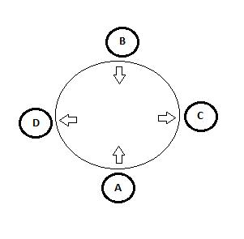

There are 5 questions:  
?2D ==> who is standing opposite of D? Ans:C  
?3C ==> who is standing immediate left of C? Ans:B  
?4B ==> who is standing immediate right of B? Ans:D  
?5A ==> is A facing inwards? Ans:Y  
?6B ==> is B facing outwards? Ans:N  
Finally printing all answers in a single line separated by semicolon.

Example 2

Input

2  
4BA;3CA;3CD;5C;5B  
?5A;?3D;?4C;?6B

Output

ARRANGEMENT NOT POSSIBLE

Explanation

We can arrange 4 people in two different ways as the image below, from the facts provided. Directions of A and D can be set differently.

